BTA 420 Project – Group 2

# Sportsy - sports equipment rental system

**Elizabeth Golconda**

**Leo Vasquez Garcia**

**Heena Patel**

**Karen Wilkson**

**Winter Term 2022**

## Table of Contents

Section 1 Introduction

Section 2 Project Management

Gantt Chart

Network Diagram

Risk Management Plan

Section 3 Planning & Selection

Baseline Project Plan Report

Project Scope Statement

Project NPV

Section 4 Determining System Requirements

Interview with Rental Returns Manager

Section 5 Modeling Business Processes

Context Diagram

Level 1 Diagram

Section 6 Data Modeling

Entity-Relationship Diagram

Section 7 Designing the Interface

User Interface Mockups

Section 8 Database Design & Physical Design Parameters

Section 9 Implementation & Operation

Documentation, Installation, Support & Training Plans

Section 10 New Tools & Approaches

UML: Use-Case Diagram

UML: Class Diagram

Proposed Marketing Plan

Appendix Q&A

## Project Section 1: Introduction

It is our pleasure to have this opportunity presented to us. Rose City Consultants is ecstatic to discuss further our new approach for Sportsy, which supports and enhances the company’s growth and online success. Our strategy involves maintaining the current success of the online platform and establishing a presence in the rental market. We want to ensure our strategy best aligns with the current shift in the market from buying to renting. In turn, this will accommodate a wider range of consumers by offering lower prices, those interested in sports, and those who are hesitant of ownership while maintaining a channel in which we can improve sales. We hope our information systems and the integration with Sportsy’s existing systems will successfully form a long-term strategy.

## Project Section 2: Project management

In this section, we introduce the Gantt chart, the list of tasks and their subtasks, and the network diagram.  The Gantt chart summarizes the timeframe of the project and the high level activities; the entire project spans about 5-6 months. Slack time is represented by the black lines in the Gantt chart.

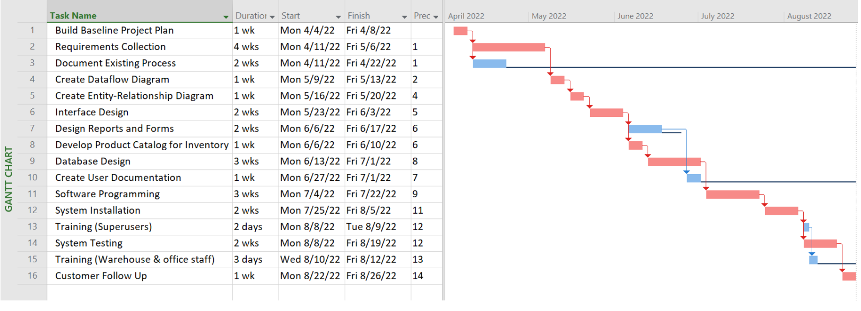



Below we have summarized these activities with their related sub-tasks. Note that each sub-task fits within its primary task timeframe:



The Network Diagram is a visual representation of the flow of activities. The white boxes represent activities that will overlap with another activity. These steps can be achieved in parallel and will save a couple of weeks of time on the overall project.

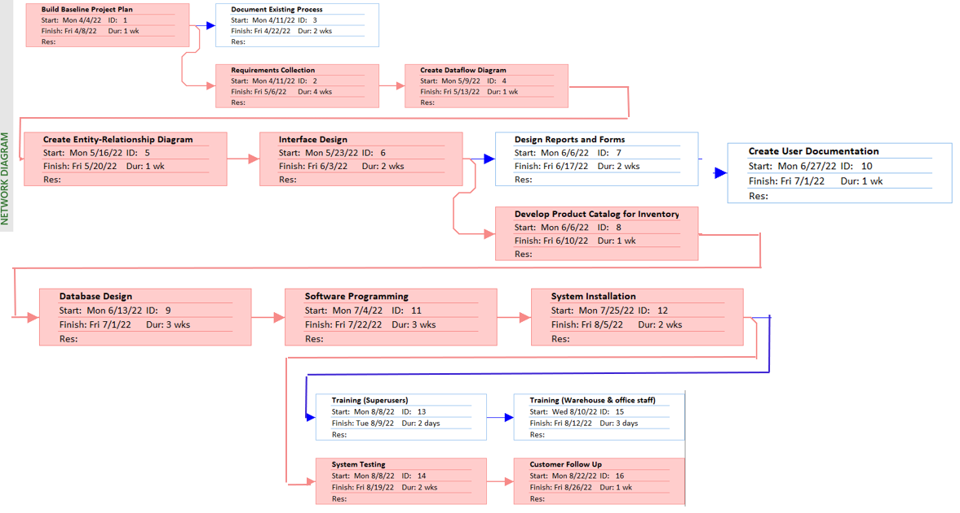

**We have also identified several potential risks and our mitigation plans associated with them:**

* *Project timeline slips due to unforeseen supply chain issues with labor or materials*
  + We have identified 2 additional suppliers for the materials we plan to use in our project, and as we use them on other projects, they are readily available to provide necessary equipment at a similar cost as our current supplier.
* *Unexpected cost increases for labor or materials*
  + We currently have a Not-to-Exceed agreement with our suppliers; any unforeseen increases (driven by economic situations outside of our control) will be immediately communicated to Sportsy, and we will meet to create an action plan to mitigate costs.
* *Tech issues with integrating software*
  + Our suppliers have staff committed to supporting the project on a 24/7 basis.
* *Additional changes requested by customer (scope creep)*
  + Rose City Consultants will perform as per the items in the contract; we will meet with Sportsy to address any adds or changes to the scope of the project.
* *Alignment issues between user groups*
  + We have set up regular project team meetings with Sportsy’s CEO as well as the Rental Returns manager. We expect to work closely with the Rental Returns manager in all aspects of the project and include him in the design and build process.
* *User resistance in adopting new software*
  + We will do our due diligence upfront during the requirements gathering process to incorporate as much user input in the process as possible. We see this project as a team effort with Sportsy and expect to partner closely with users to help them with the new tool.
  + We will also provide comprehensive Superuser and User training on the backend to ensure that Users are comfortable with the new tool.

## Project Section 3: planning and selection

In this section we have provided the Baseline Project Plan, the Project Scope Statement, and the NPV.

|  |
| --- |
| **Baseline Project Plan Report** |
| ***Introduction***   1. Project Overview: Rose City Consultants will be developing an online rental portal for Sportsy to rent sports equipment on a monthly basis paid program. The rentals can select from the range of equipment’s that are displayed in the portal. 2. Recommendation: Rose City Consultants, recommends that Sportsy reviews the Project Plan and give feedback on the System Description, Feasibility Assessment and Management Issues listed below |
| ***Systems Description***  a. Alternatives: Some alternatives are:  1) Purchase the system if one could be found that meets your needs,  2) Outsource the development of the system to an outside organization,  3) build the system within Sportsy.  The System requirements is to install hardware, software, and databases, prepare data, and validate the system. Current system functionality, processes, and data-use requirements for performing customer tracking activities. They comprise of:  1. Web-based online system  2. Mainframe with central database  3. Local area network with decentralized databases  4. Batch data input with online retrieval  5. Purchasing of a prewritten package   1. System Description: The system-related development costs as either one-time or recurring. A one-time cost refers to a cost associated with project initiation and development and the start-up of the system. These costs are as the following activities:   System development  New hardware and software purchases  User training  Site preparation  Data or system conversion |
| ***Feasibility Assessment***   1. Economic Analysis: With the implementation of our software there are benefits that can reduce the workload by automating monotonous jobs, reduce errors, provide innovative services to customers and suppliers, and improve organizational efficiency, speed, flexibility, and morale. Some of the examples of tangible benefits include reduced personnel expenses, lower transaction costs, or higher profit margins. 2. Technical Analysis: The proposal is to construct the website with the available equipment for renting via the web application built in .Net application 3. Operational Analysis: Sportsy website will be able to navigate to the desired tabs and pages and with ease. 4. Legal and Contractual Analysis: With the use of the webpage, Sportsy will be able to capture the right type of equipment for rental and deliver in the scheduled period. 5. Political Analysis: The stakeholders can assess the Project Plan Report and advise Rose City Consultants of concerns that may arise from implementing the website. 6. Schedules: The schedule will start per the Gantt chart provided |
| ***Management Issues***   1. Team Configuration and Management: Rose City Consultants will be having a team of 12 people which includes: Project Managers / Business Analysts / Business Systems Analysts / Developers / Quality Assurance Analysts / Test Leads. 2. Communication Plan: Rose City Consultants will be using centralized project management tool JIRA to communicate the phases of the projects. 3. Project Standards and Procedures: After Sportsy approves the Project Plan Report will follow-up on any ongoing changes through the documentation of Change Management documentations in JIRA. 4. Other Project-Specific Topics |

## 

## 

## Project Section 4: Determining system requirements

This section utilizes Sportsy’s list of requirements and constraints for the online rental system. After analyzing this list, we have prepared an outline of our interview with your Rental Returns Manager. We have also included the outcome (answers) from that interview.

**Requirements**

* Recommending new sports equipment to rent based on previous rentals
* Easy for customers to rent equipment online without having to call us
* Easy to integrate with our existing website on the front end
* Needs to facilitate updating the returned equipment quickly in our warehouse system and on customer profiles
* Needs to track any damage to equipment caused by customers after every rental
* Easy to track and flag overdue rentals
* Easy to integrate with credit checks

**Constraints**

* Staff to implement – we only have two IT employees
* Training needs to be done in phases, as we need staff to operate the sales side of the business
* Needs to integrate with our warehousing system



## Project Section 5: modeling business processes

In this section, we present the high- and low-level business process models, which outlines the activities that take place in the system as a result of the customer initiating an order.

Sportsy’s Rental context diagram contains only one process which includes customer and rental equipment manager as the only two sources. The single process, labeled “0”, represents the entire system. When the customer has ordered, it is received by the sports equipment rental system. Once the order is processed, the receipt will be processed and sent to the customer while also sending the rental equipment order to the rental equipment manager.

Sportsy’s Rental level 1 diagram is a generation of nested decompositions based on the receiving and transformation of a customer’s rental order. Process 1.0 is broken down into 4 subprocesses: 1.1 browse rental catalog, 1.2 update rental cart, 1.3 determine rental duration, 1.4 conduct credit check. This is the process in which a customer places an order and is then met with several processes that are required from the customer to successfully placing an order. The level 1 diagram also indicates the continuation into process 2.0 and 3.0 as all subprocesses of process 1.0 have been achieved.

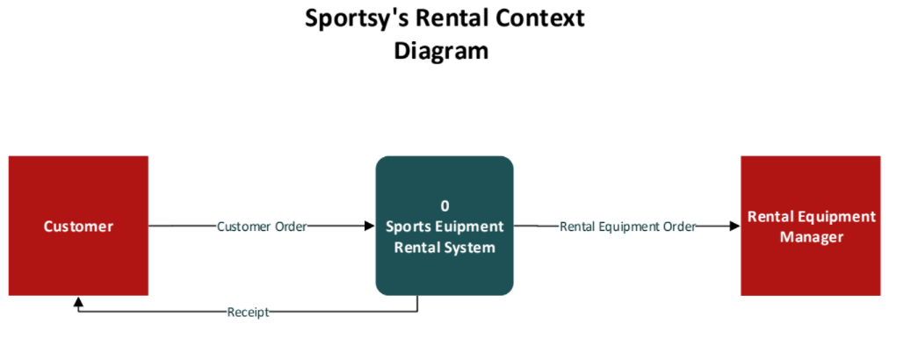

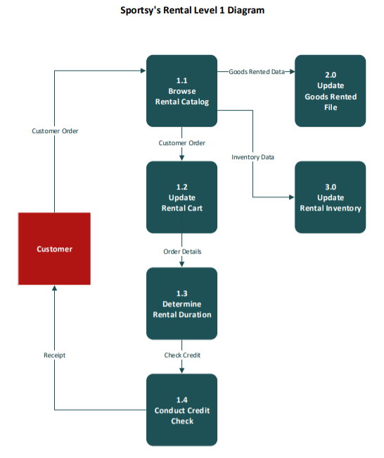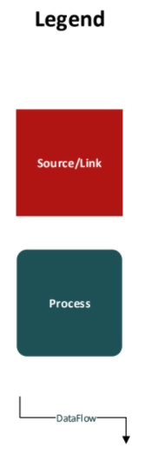

## Project Section 6: Data modeling

In this section we present and explain the database entity-relationship diagram, including the entity-relationship model with the details on how the system database will interact with all users of the system: Customer, warehouse employees, and rental returns manager.

Below is the relational database model representations data in the form of related tables or relations for the Sportsy’s Rental online store. A customer is someone who rents rental products from Sportsy. Customers include online customers and that they can be either individuals or businesses.

For every customer, their credit history is one time needed to complete and hold a credit report to make sure we can rent our products to them. There is just one credit report per customer which system will save the credit history ran by and provided by the third party called Equifax. Once the credit report eligibility approves, the customer is all set to rent the equipment.

Customers will have access to all the available rental equipment with its starting date with the days it will be rental for and with the timestamp for the inventory updates in the inventory table. Once the customer chooses and picks the rental equipment which will update the rental table through foreign keys of the customer _id and rental equipment ID. which will pass on to the tunnel to the payment table where customer will make a payment with the options for making full payment or pay over time for rental equipment. Once the payment is made, the order system will be updated with the information with customer_ID, product description with the quantity and the shipping address. The delivery table will be updated once the shipment is ready to be shipped and the shipment is delivered. The delivery providers are UPS, FEDEX or USPS and the vendors will be determined based on the cost analysis of the equipment rented. The system will provide the two delivery types: standard and express. A coupon is a special promotion that can be applied to the rental that is created for a specific customer. It is created for a set dollar amount, for example $10. We need to track the reason why a coupon was given to a customer whose order got delayed with the delivery or received a damaged rental product. Only one coupon can be used per transaction, but customers can have many coupons. In the backend the employees will update the inventory with its timestamp.



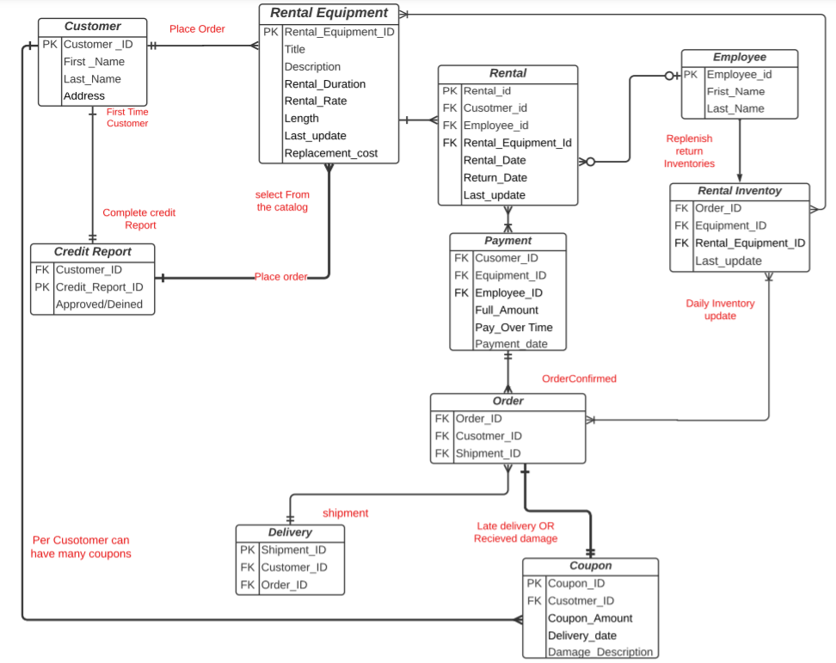

Project Section 7: designing the interface

In this section we provide the mockups of the customer’s view of the rental interface. Also included for your reference are screen descriptions.

**1:** **Introductory screen** – this is the first place the customer will see. Prospective customers will be prompted to click links for membership information, how to join, and how to get support.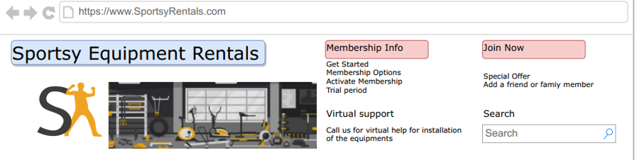

**2:** **Equipment rental information and catalog** – this screen provides an opportunity to view the equipment for rent, and additional information on rentals.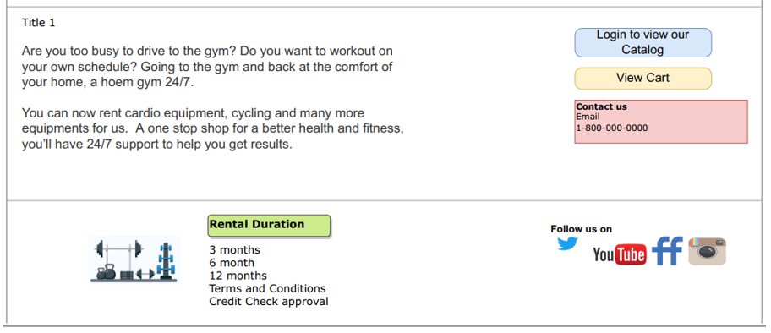

**3. Customer payment screen** – this screen allows the customer to securely add their payment information. Once their payment data is entered, the customer has the option to permit Sportsy’s system to save their payment data.

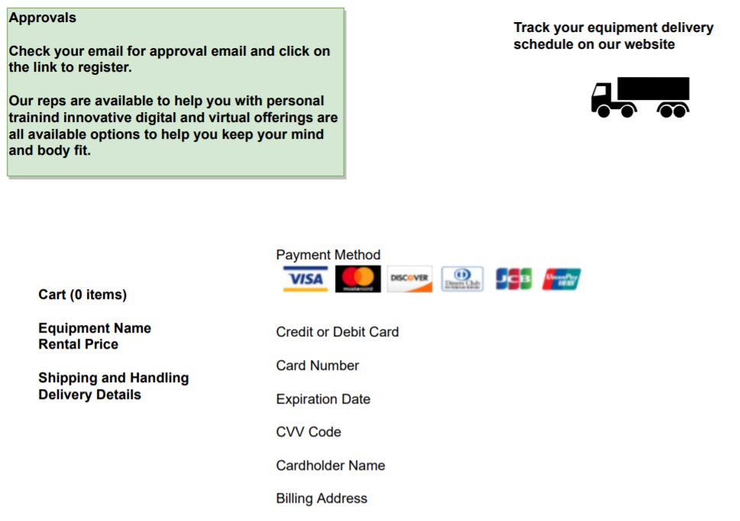

**4. Promotional screen** – when a customer reaches this screen, they will see Sportsy’s current promotions. Users can log into the system to access promotions as well as customer service to sign them up.

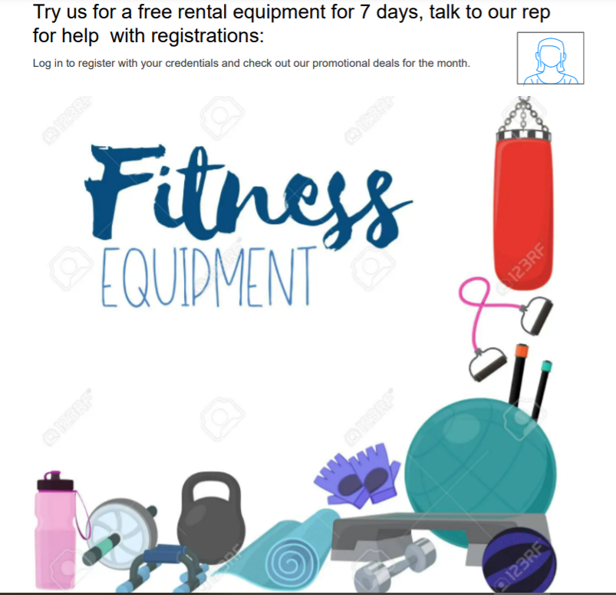

**5. About the Company** – this screen allows customers to read more about Sportsy: you can add your company history, locations, customer benefits and motivational dialogue here.

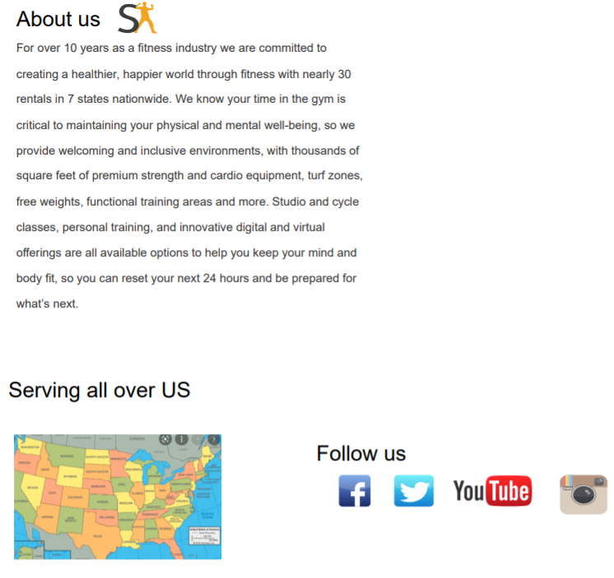

## Project Section 8: database design

In this section we provide tables to depict the physical design parameters of the system database. These tables present the lowest level of detail for the database entities and attributes, and will be useful for designing the system upfront as well as system maintenance going forward.

Below you see Physical Design parameters which is the transforming of logical data models into physical data models. This design indicates the design of the fields and translates the logical description of data into the technical specifications for storing and retrieving data. Efficient database performance relies on adequately defined fields and subsequently relies on adequate specifications for each field.

We have also provided a product entity type with its attributes. For this entity, its respective primary key is the Product ID.

**Physical Design Parameters**

**Table w/ Attributes**

## Project Section 9: implementation and operation

In this section we have provided a number of important items related to system implementation and operation, including documentation, installation, support, and maintenance.

*1) Recommendation for end users’ documentation:*

The end users’ documentation we recommend is written and visual information about the application system. The end users’ guide consists of how the system works and how to use it. The written training course documentation will be uploaded in the latest version of word which can be helpful for the user/users with hearing disability and the users who are more visual have an option to download the training videos or watch them online at their convenience. Rose City Consultants also provides their own website portal to provide additional user-guide content.

While preparing both the version of user-guides we considered the highest quality of the source documentation and focused on the information system’s functionally and on the tasks the system can be used to perform. This way we are opening doors with multiple options for various background end-users to troubleshoot the issues independently which will reduce further training and consulting cost.

*2) Installation recommendations:*

By looking at Sportsy complex business model which runs 24 X 7, we would recommend Phased installations as better planning, control, and testing can be done for each page of the website before rolling out the solution to end users. Phased implementation also gives your organization greater control of how to plan for the solution’s overall cost and determine what modules to roll out which will limit the potential harm from the system error or failure to certain business activities/functions. This approach will also spread out the risk over time and manageable as the deployment will go live for each break-down phases during off-hours and will not disrupt the business activities.

*3) Support issues to be considered:*

Rose City Consultants considered support is more than just providing help desk; answering user questions about how to use a system to perform a particular task or about the system’s functionality. Support also consists of such tasks as providing for recovery and backup, disaster recovery and PC maintenance; writing newsletters and offering other types of proactive information sharing; and setting up user groups. We will take in charge of new system all forms of support are in place before system is installed. Also considering the small business with limited staff we can provide as many services as possible like write backup and recovery procedure and schedules. We can also take responsibility of their hardware; we have professionals who can maintain software and hardware.

*4) Factor influence maintenance and its challenges:*

Numerous factors can influence the maintainability, below are general challenges that companies face and influence the maintenance for new system

- Latent defects – This is the number of unknown errors existing in the system after it is installed.

- Number of customers for a given system – In general the greater the number of customers the greater the maintenance costs.

- Quality of system documentation- Without quality documentation, maintenance effort can increase exponentially. Quality documentation makes it easier to find the code that needs to be changed and to understand how the code needs to be changed. Good documentation also explains why a system does what it does and why alternatives were not feasible, which saves wasted maintenance efforts.

Above discussion on maintenance applies to any type of information system no matter on what platform it runs. But when it comes to website management some special issues and procedures are needed because of their nature and operational status. These issues are included below:

1) 24 X 7 X 365 – An e-commerce website has the advantage of continuous operation; thus, maintenance of pages and the overall site usually must be done without taking the site offline. However, it may be necessary to lock out use of pages in a portion of a website while changes are made to those pages.

2) Check for broken links – The most common maintenance issue for any website (besides changing the content of the site) is validating the links from the site pages (especially for links that go outside the source site) are still accurate. Periodic checks need to be performed to make sure active pages are found from all links and periodic human checks need to be performed to make sure the content found at a still-existing referenced page is still the intended content.

3) Reregistration – It may be necessary to reregister a website with search engines when the content of your site significantly changes. Reregistration may be necessary for visitors to find your site based on the new or changed content.

4) Future editions – One of the most important issues to address to ensure effective website use is to avoid confusing visitors. Especially frequent visitors can be confused if the site is constantly changing.

Project Section 10: New tools and approaches

As we approach our final segment in this system presentation, we are including the requested Use-Case diagram and the Class Diagram based on your interest in UML. We realize that UML is becoming a more popular approach to system design.

The Use-Case diagram depicts the interaction between Actors (users) and the various use-cases within the Sportsy equipment rental system.

**Use-Case Diagram**



A **Customer** uses the **Online Equipment Rental Portal** to shop and then place an order for the sports equipment they wish to rent.

The **Online Equipment Rental Portal** receives the order and supplies rental data to the **Warehouse Inventory System** and to the **Sales System**.

The **Rental Equipment Manager** receives the customer’s order using the **Warehouse Inventory System** and ships it to the customer.

The **Rental Returns Manager** receives returned equipment and returns it to the **Warehouse Inventory System**.

The **Data Analyst** retrieves sales data from the **Sales System** upon customer’s order, and also retrieves rental data from the **Warehouse Inventory System**.

Both the **Warehouse Inventory System** and the **Sales System** provide sales and inventory information that the **Data Analyst** can use to estimate and forecast for future rental equipment needs.

**Class Diagram**

The Class Diagram represents the system as a collection of objects, all sorted by their class (ie: a set of objects that share a common structure and a common behavior, as well as their internal structure and their relationship to other classes, and is similar to the E-R diagram. However, the difference is the Class Diagram functions in a modelling environment representing objects.



Finally, per your earlier request, we are including a high-level marketing strategy. We believe this will help your analytics team utilize the data from your new system (and eventually to use machine learning) to identify the most favorable target markets.

**Proposed Marketing Strategy**:

1. Update current website to notify customers of new business venture.
2. Announce your planned expansion into sports rental equipment via multiple channels:
   1. Get the word out using your social media accounts (Facebook, Twitter, Instagram page).
   2. To existing customers by e-mail and/or regular postal service.
   3. To potential new customers by advertising on TV, billboards, mailers.
3. Have a grand re-opening event and heavily advertise the event beforehand through above recommended channels. Call the local news stations to have coverage on the day of the event; emphasize that a local small business is launching a new venture.
4. Run an introductory sale for existing clients who may now wish to rent equipment they may have wanted to try out before but didn’t want to commit to a purchase.
5. Provide a rental rewards program such as frequent rentals cards, rent one get one free, etc.
6. Gather, as part of the rental process, information on customer demographics.
7. Once you have built up enough rental statistics, use the data to establish target markets (customer data, best locations to advertise).
   1. Once target markets are known and you are ready for the next step, utilize machine learning to define best demographics to direct advertising to, best time for running sales, and best places to advertise.
8. Capitalize from positive Yelp reviews and customer word-of-mouth.

We would like to extend our sincere gratitude for allowing us to present you with our plan for the new equipment rental system for Sportsy. We believe Rose City Consultants will be a fantastic partner in your new online sports equipment rental enterprise.

## Project Appendix: CEO Q&A

**Section 1:**

How much inventory will be held for consumers that are purchasing compared to rental equipment?  
This is a good question, our goal is to provide all the needs for the rental consumers, and we will make the rental inventory grow over time, but we have a threshold of the rental inventory of 25-30% of all of our inventory depending on the equipment type and cost.

Would it be possible to reduce the quality of equipment and increase quantity to maximize the benefits during the rental market's high demand?  
No, we provide high-quality equipment, and we need to keep out a good reputation in the market.

**Section 2:**

In developing the new system requirements, we'd like to know whether there are any features or business processes in your current system that are non-negotiable; that you must keep?

Most of the current features I would like to keep, but we have a company that acts as a financial middleman between our website and our customer. The company helps us facilitate the completion of online transactions and the processing of online payments. However, we hope to have an online payment system that includes: payment gateway, payment processor, payment provider, payment service, and merchant account. That will be great.

**Section 3:**

Please let me understand the Economic Benefit Analysis that you are looking for: Are you asking for an NPV that spans the project development time frame (5 Months)? Or are you asking for an NPV that spans roughly 5 years?

On 3/7/22, Rose City Consultants and the CEO aligned verbally over zoom on what to submit for the NPV, and that version is included in this project review.

**Section 4:**

Are you planning to provide customer with recommendations (ie: based on prior rentals)?

This is a part of the analytic feature, and we are not planning to do that in the first two years, but in the future, yes, once we have enough data and we know the business well.

How do you want to handle order anomalies (ie: someone orders twenty bike rentals instead of one or two)?

The customer can do that if we have enough number and of course we give it a high priority

Will machine learning play a part in your business plan (ie: predicting trends in equipment types)?

This is in the future plan, not in the first stage

Will your business plan allow automatic approval of credit cards, or do you plan to do that manually?

We would like to have a great an online payment system that includes: payment gateway, payment processor, payment provider, payment service, and merchant account, which make this more efficient and automatic.

**Section 5:**

What reports would you like to see in the management system?

**Section 6:**

How are we planning to handle rental/return equipment inventories? Are we creating inventories entity in the new system?

Yes, we will have a rental/return equipment inventory as a different entity from the other inventory in the new system even though both will be at the same warehouse.

Also, are we envisioning that a webstore would be tied up with smartphone apps to increase sales?

For now, we will just have the website, and we do not think we will do the app, but it could be in the future.

**Section 7:**

How are we addressing feedback and comments that renters rate on Yelp?

The customer service group handle this task where they keep tracking the customers' feedback and try to address them by reaching out to that customer and seeing what's going on. one of the solutions, if we do mistakes, is providing coupons to these customers and try to improve the services in the future.

How do we handle transactions that the credit card declines for recurring charges?

**Section 8:**

Many database management systems offer the ability to enforce referential integrity. Why would using such a feature be a good idea for Sportsy? Are there any situations in which referential integrity might not be necessary?

Depends on the cost of this and I am open for any recommendation or suggest from you just please include the cost and pros and cons. (*Rose City Consulting note: This was clarified with the CEO on 3-7-22 that the tables included the primary keys, which already showed referential integrity*)

**Section 9:**

What would be the best time to have a system down for upgrading the website?

The installation will be after midnight to 6-7 am and not during the weekend. and this time also is the best since it has low traffic.

**Section 10:**

What is your marketing plan (ie: demographic based, other)?

That is a really good question, and I do not have an answer and we will appreciate that if you can recommend something about this. **\*\*Rose City Consultants has provided a marketing plan recommendation in Section 10: New Tools and Approaches\*\***